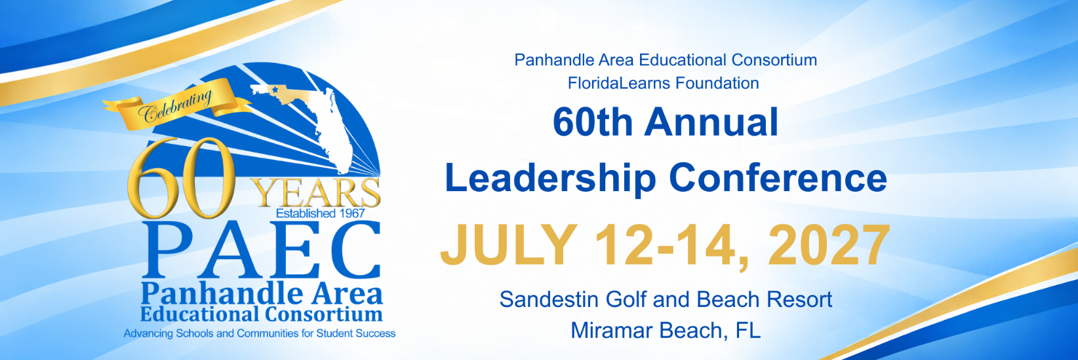
Conference Partner Contract
Name of Company:
Company Address:
City: | State: | ZIP:
Billing Address (if different than above):
City: | State: | ZIP:

Name of Authorized Company Representative: Title:

The conference partner assumes the entire responsibility and liability for losses, damages, and claims arising out of partner’s activities on the hotel premises and will indemnify, defend, and hold harmless the hotel, its owner, and its management company; PAEC; the FloridaLearns Foundation, Inc., as well as their respective agents, servants, and employees from any and all such losses, damages, and claims. Neither Baytowne Conference Center Grand Complex, nor any of its representatives or employees, will be responsible for any injury, loss, or damage that may occur to the exhibitor, their employees, or exhibit materials from any cause whatsoever, either prior to, during, or subsequent to the event. This includes any and all claims for monetary reimbursement.

Authorized Company Representative: ______________________________ Date: _______________

Signed contract MUST be received prior to the conference.
Please mail or email to: Charles Walker
FloridaLearns Foundation
P. O. Box 243
Chipley, FL 32428
Charles.walker@paec.org

